AI-Assisted Threat Detection Dashboard
Using Google Cloud Platform (GCP)
ARCHITECTURE AND WORKFLOW REPORT
Project Domain
Artificial Intelligence | Machine Learning | Cybersecurity | Data Analytics

SYSTEM ARCHITECTURE
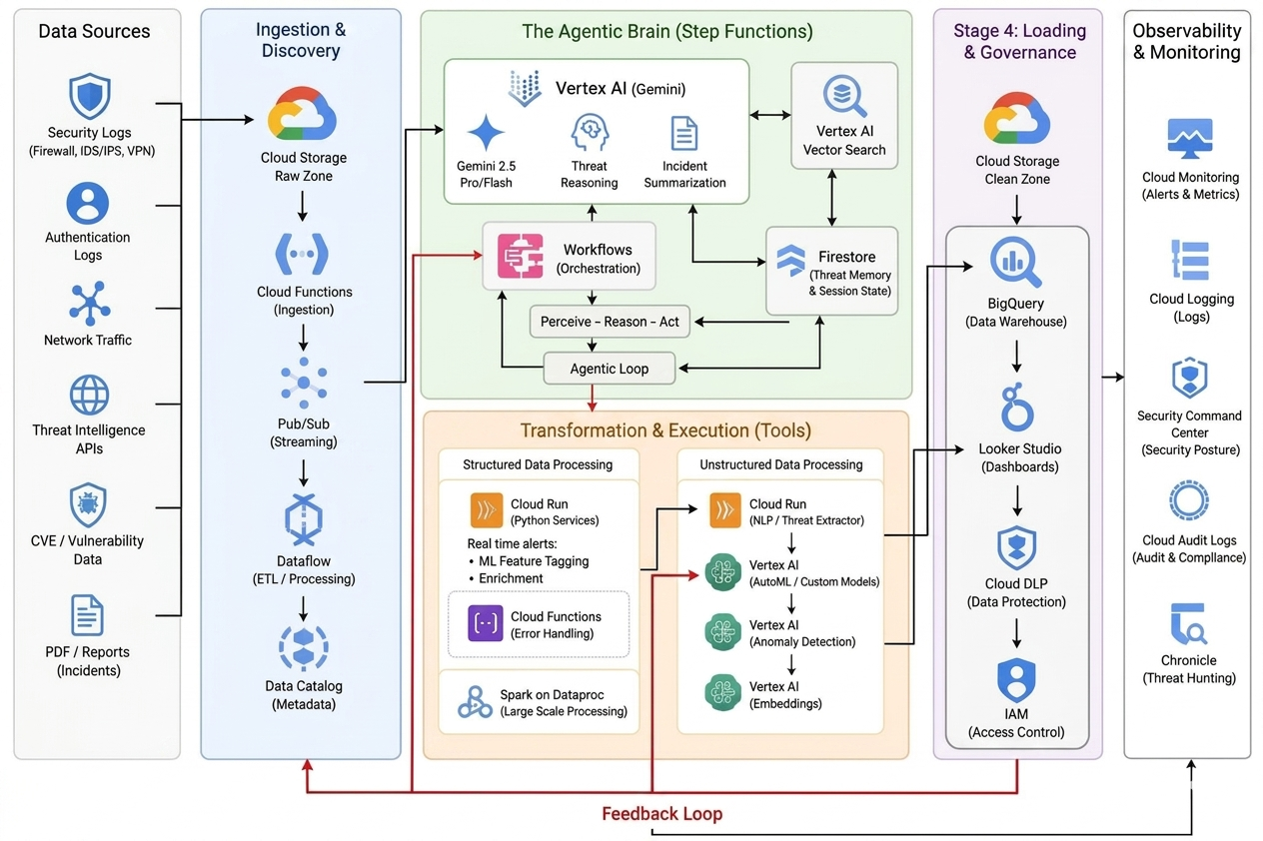

Explanation
The proposed solution is a cloud-native security analytics pipeline deployed on Google Cloud Platform. It continuously ingests security logs, processes structured and unstructured events, applies machine learning to identify suspicious behaviour, and presents actionable insights through an interactive dashboard. By combining automated orchestration, Vertex AI services, and governance components, the architecture provides scalable threat detection while maintaining data privacy and compliance.

WORKFLOW
START
Security Logs Generated
Cloud Storage (Raw Zone)
Cloud Functions Trigger
Pub/Sub Queue
Cloud Dataflow Processing
Cloud Run Enrichment
Vertex AI Anomaly Detection
Gemini + Vector Search Reasoning
Cloud Firestore
BigQuery
Cloud DLP
Looker Studio Dashboard
Executive Reports
END

STEP-BY-STEP WORKFLOW EXPLANATION

Step 1: Security Log Collection
The workflow begins with continuous collection of firewall, VPN, authentication, network traffic, and threat intelligence logs. These events are stored in the raw storage layer to ensure reliable ingestion.

Step 2: Event Trigger and Queueing
Whenever new logs arrive, Cloud Functions automatically trigger and publish the events to Pub/Sub. This asynchronous messaging layer absorbs traffic spikes and enables fault-tolerant processing.

Step 3: Stream Processing
Cloud Dataflow consumes messages from Pub/Sub, cleans inconsistent records, standardizes formats, removes duplicates, and prepares the data for downstream analytics.

Step 4: Feature Enrichment
Cloud Run enriches the processed logs by adding contextual metadata, extracting security features, and preparing structured inputs for machine learning models.

Step 5: AI-based Threat Detection
Vertex AI analyzes the enriched data to detect anomalous behaviour using trained models. Events that significantly deviate from normal activity are flagged for further investigation.

Step 6: Intelligent Reasoning
Gemini and Vertex AI Vector Search correlate detected anomalies with historical incidents, attack patterns, and contextual knowledge to generate meaningful threat summaries. Firestore maintains the reasoning state.

Step 7: Secure Storage and Governance
Validated results are stored in BigQuery. Cloud DLP masks sensitive information before it is made available for analytics, ensuring regulatory compliance and secure data handling.

Step 8: Visualization and Reporting
Looker Studio retrieves processed information from BigQuery to display real-time dashboards, trends, and risk metrics. Security teams can monitor threats and generate executive reports.

